 2025
NAME:

ALGORITHMICS UNIT 4
SAC 3: Computer Science, past and present
Unit 4 Outcome 3

Date of Completion: 6-10 October 2025

Reading Time: 5 minutes
Writing time: 55 minutes
TOTAL: 60 minutes

QUESTION AND ANSWER BOOK

Type | Number of  questions | Number of questions  to be answered | Number of marks
Short/Extended Response | 8 | 8 | 25
 |  | Total | 25

Materials supplied
Question and answer book of 7 pages
Materials permitted
Pens/Stationary
No calculator or reference material permitted.

Student declaration: This SAC is my own work and has been completed according to the stated requirements.

Signed:……………………………………………………………………………..

1. Calculate the activation value for neuron o₁, given that i₁ = 1 and i₂ = 4.
i₁
2
o₁

3
i₂₂

(1 mark)

2. Describe two reasons for the resurgence of neural networks in the late 20th century.

(2 marks)

3.
(a) Describe the criteria for a machine to pass the Turing test.

(1 mark)

(b) Explain whether or not passing the Turing test implies that we have created Strong AI.

(2 marks)
4.
(a)
“The Halting Problem only applies for a very specific, artificially constructed example. It doesn’t show any meaningful boundaries on computing power.” Give an argument explaining why this view is incorrect.

(2 marks)

(b)
“I’ve written a program which is 100% hacker proof.” Explain, with reference to concepts from the course, why this is impossible to guarantee.

(2 marks)

5. Compare overfitting and underfitting by SVMs by discussing how well they fit training data and unseen data.

(3 marks)

6.
(a)
“This data is not linearly separable because you can’t draw a line through it to separate it.” Explain whether or not this is correct.
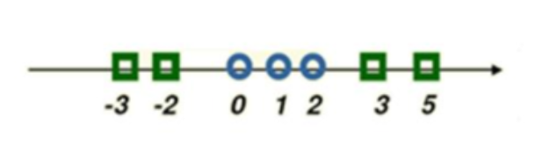

(2 marks)
(b)
“This data is too mixed up, you can’t draw a plane between the orange and blue points which means it can’t be linearly separable.” Explain whether or not this is correct.
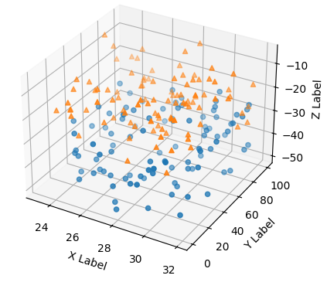

(2 marks)
7.
(a) Searle’s Chinese Room Argument asks us to consider a man in a room who interprets Chinese characters so that his responses appear to be those of a Chinese speaker, however, he does not understand the language. What point is Searle trying to make with this argument?

(2 marks)
(b) Compare the robot response with the systems response, clearly stating one similarity and one difference.

(2 marks)

8. The army has developed an app for deciding who to treat first in a mass-casualty situation. A medic enters the injuries and vital signs (heart rate, blood pressure etc.) of a casualty, and the app uses a neural network to work out what resources should be allocated to this casualty compared to other casualties.
Discuss whether or not this is better than letting medics decide for themselves how to allocate resources among patients. Your answer should consider transparency, bias, fairness and human dignity. (Do not consider the privacy or technical aspects of this problem.)

(5 marks)

